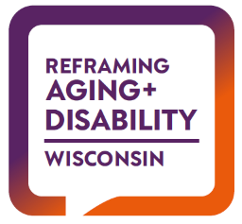

Wisconsin Reframing Examples

Bureau of Aging and Disability Resources Website
making changes

PRE-Reframing

The Bureau of Aging and Disability Resources (BADR) is responsible for the development of policy and the management of programs that serve persons who are elderly, persons with physical disabilities, persons who are blind or visually impaired, persons who are deaf, hard-of-hearing or Deaf-Blind, persons in need of adult protective services and persons who need or receive information about or access to community-based long-term support through an Aging and Disability Resource Center. BADR carries out its responsibilities under contracts with multiple federal agencies in a way that actively promotes individual choice, dignity, relationships, overall health, community participation, self-sufficiency and respect. BADR works closely with other units of the Department of Health Services to implement the long-term care reform proposals that utilize the aging and disability resource centers (ADRCs) as single points of entry.

Carrie Molke, Director
1 W. Wilson Street, Room 551
Madison, WI 53703

BADR consists of the following three sections:
Office on Aging (OOA)
Office for the Promotion of Independent Living (OPIL)
Office for Resource Center Development (ORCD)
Related pages
- Division of Public Health (DPH)

POST-Reframing

The Bureau of Aging and Disability Resources (BADR) moves our state forward in upholding our right to participate fully in our community as we age or experience disability. We partner with an extensive network of experts and advocates to build policies, structures, and systems that support our needs as they evolve over the course of our lives. Together, we chart a healthier path forward for everyone.
The Bureau administers programs and services in support of this mission including:
- Assistive technology to help us be successful at our job and to live safely in our homes if we are blind, deaf, deaf-blind, hard of hearing, or experiencing a different disability.
- Information, assistance and counseling about our options to secure support through community-based long-term services, when needed.
- Adult protective services that reinforce our right to self-determination.
- Support for family members and friends when caring for a loved one at home.

The Bureau works closely with all our partners and other units in the Department of Health Services to develop policies that are responsive to our needs as we age and/or experience disability and effectively promote continued participation and contribution in the community.

Carrie Molke, Director, 201 E. Washington Ave, Madison, WI 53703

