Digital Click Counter

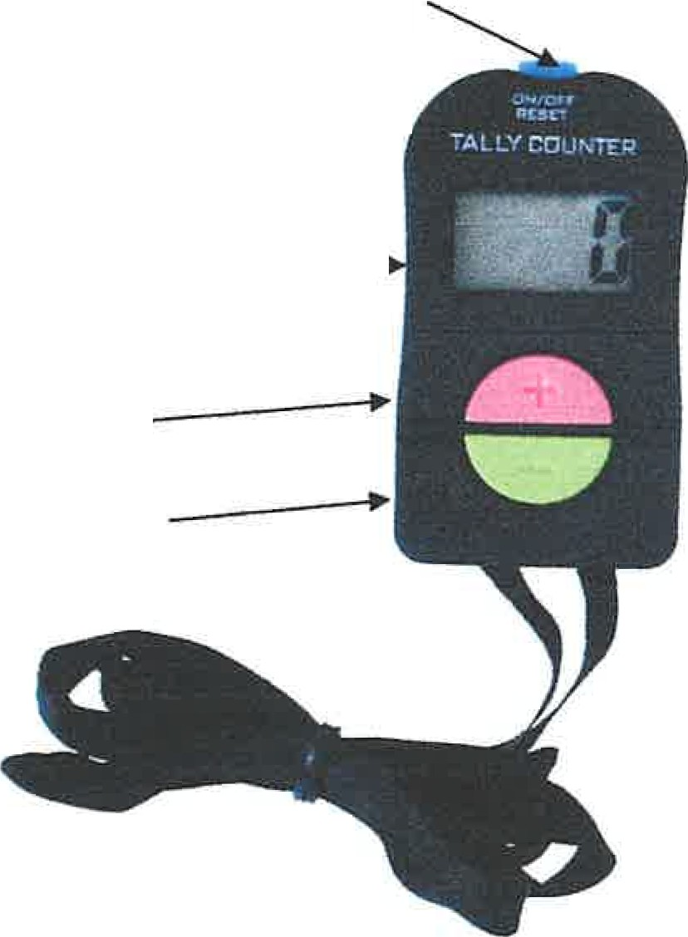
On/Off/Reset (blue)

Display ----
Count + button (pink)
Count - button (green)

Turn on: Press On/Off/Reset (blue)
Display will be O(zero)
To count: Press+ button (pink)
Will beep each time pressed
To turn beep OFF or ON
Hold + button (pink) down for 3 seconds
To clear counter and set display back to O (zero):
Hold On/Off/Reset (blue) button down for 3 seconds
Turn off: When display is at O (zero)
Hold On/Off/Reset (blue) button down for 3 seconds
Use - button (green) to take away a "count mistake”

To complete BEFORE the workshop starts:

Please use your click counter to count the total number of times you stand up for 2-3 days prior to the start of the workshop. Please include ALL times you stand up naturally throughout your day. (I.e., Stand to go to the toilet. Stand up from the toilet. Stand as you get out of bed. Stand as you get out of the car.) Try not to stand more times than you usually do. The number you get will serve as your “baseline” which we’ll work to increase through the workshop. Each time you stand, press the pink + button. At the end of the day, record the total number of times you stood throughout the day here. Then reset the clicker for the next day.

Day 1: ___________

Day 2: ___________

Day 3: ___________

