Social Isolation and Loneliness Awareness Week Toolkit 2022

This toolkit was prepared by the Wisconsin Coalition to End Social Isolation and Loneliness. You can learn more about our coalition here. Social Isolation and Awareness Week takes place November 13 – 19, 2022.

The toolkit was designed so that you can pick and choose the resource(s) that makes the most sense for your work and what you want to do during awareness week. You will find areas that are yellow-highlighted - these sections prompt you to add in your own specific details. Please feel free to use this toolkit as a guide and modify as needed. Please reach out to Carleigh Olson (carleighs.olson@dhs.wisconsin.gov) with any questions.
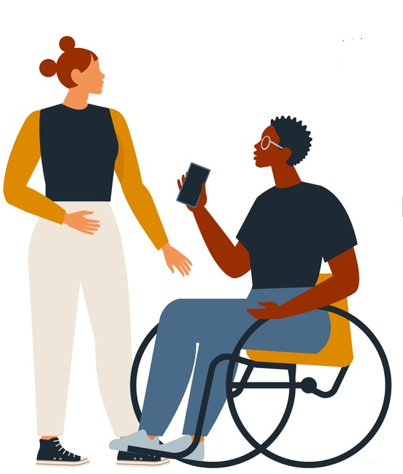
Table of Contents

Item: | Suggested use and timing:
Letter to the Editor (LTE) | - Visit your local paper’s website and look for a section titled “opinion” or “editorial”. From there you should see instructions for how to upload.  - Try to time publishing with SIL Awareness week - Nov 13 – 19
Press Release | - You can send your press release to your local media stations at the start of awareness week.  - To find contact information, visit your local media website(s).  - Be prepared that if media wants to cover the story, you will get contacted!
Radio Scripts | - These radio scripts can be used if you want to get radio spots during awareness week.  - You can contact your local radio station(s) and suggest that they run these as public service announcements (PSA).
Talking Points | - You can use these if you get asked questions about awareness week. These will also be helpful if you get a request for an interview based on your press release.
Connection Tips Images | - There are many ways you can use these. Some ideas include on your organization’s social media pages or in a local paper.
Data/Background information on social isolation and loneliness | - You may use the background information in many ways. One idea is that you can use some of the data/background information found in this toolkit as the text alongside the images.
Resources | - These resources can be used as you see fit!  - This is not a comprehensive list of all resources that exist. There are many and we have selected some to feature during awareness week.
Summary of action steps | - When people ask you what they can do to address this issue, you can offer them one of the action steps! You can also include these with your social media or other activities throughout the week.

Letter to the Editor

Dear Editor:

At one time or another, we’ve all experienced loneliness. For most of us, it’s temporary. But for many older people and people with disabilities, being isolated and lonely is a constant reality.

In the U.S., 40% of people who have a disability and 43% of people aged 65 or older say they feel lonely some or all the time. Loneliness is associated with physical, emotional, and psychological health impacts such as greater risk for cardiovascular disease, depression, memory problems and even abuse or neglect.

So, what can we do? Let’s all remember our friends, family and neighbors - around the holidays, but afterward too. Make a phone call, stop by, schedule a video chat. Ask if they need anything - groceries, supplies for a hobby, their driveway or walk shoveled. Invite them to an activity or to join you for coffee. They’ll benefit from the human contact – and so will you.

So, get in touch and stay in touch. The simple act of reaching out and showing you care can make a world of difference for someone who is alone and lonely.

YOUR NAME
YOUR AGENCY

Citations:
Michigan University
National Academies of Sciences, Engineering, and Medicine

Press Release
FOR IMMEDIATE RELEASE CONTACT: Name – (Phone)
Date Email

(You can use this title or go with something else reflective of your local efforts)
Governor Evers Proclaims Social Isolation & Loneliness Awareness Week as Coalition Efforts Battle Growing Public Health Challenges

Loneliness and social isolation are on the rise in Wisconsin and across the United States, exacerbated by the COVID-19 pandemic. While people of all ages and backgrounds can experience loneliness and social isolation, older adults and people with disabilities are uniquely susceptible which puts them at risk for significant health problems. Governor Evers recently declared November 13-19, 2022, as Social Isolation & Loneliness Awareness Week in Wisconsin to bring attention to the growing challenges and new initiatives to support people in Wisconsin communities.

In the U.S., 40% of people who have a disability and 43% of people aged 65 or older say they feel lonely some or all of the time. According to a 2020 AARP Foundation report, two-thirds of adults in the U.S. are experiencing social isolation, with 66% reporting that their anxiety levels have increased during the pandemic. Given the scope of the problem, individuals and organizations throughout the state have joined forces to form the Wisconsin Coalition to End Social Isolation and Loneliness (WCESIL) to address the challenges and find community-based solutions.

While loneliness and social isolation are often conflated, they are distinctly different according to YOUR NAME AT ORGANIZATION and a WCESIL member. “Social isolation is commonly defined as an objective measure of the number of contacts that a person has,” says YOUR LAST NAME. “People who are socially isolated have little if any contact with other people. Loneliness, on the other hand, is a subjective feeling about the gap between a person’s desired levels of social contact and their actual social contact.” Both, YOUR PRONOUN says, are associated with physical, emotional, and psychological health impacts which include greater risk for cardiovascular events, depressive symptoms, cognitive decline, and abuse and neglect.

While there are inherent challenges in finding and supporting lonely and isolated older adults and people with disabilities, there is also strong interest in finding community-based solutions. As a start, the group encourages people to reach out to those who are isolated and may be lonely, not just during the holidays but throughout the year. Taking a moment to call, video chat or visit can make a big difference in the life of someone who lacks meaningful connections. “Our hope is that by working together, we will better understand and support people who are lonely and isolated by raising awareness, engaging in policy initiatives, and sharing detection and support strategies to reduce loneliness and social isolation and improve health and safety in the process,” says YOUR LAST NAME.

# # #
Learn more about the Wisconsin Coalition to End Social Isolation and Loneliness at https://wihealthyaging.org/initiatives/isolation-and-loneliness/
Radio Scripts
:30 Seconds
Tips to Building Connections:
Volunteer!
This is today’s ‘Tip to Building Connections …’
Why not Volunteer?
Being generous with your time and talents benefits not only the people you help. It feels great to give back to your community through mentorship opportunities and visiting programs. Contact local schools, and libraries…..even your county Aging and Disability Resource Center for ideas on how you can join others and help develop and strengthen relationships all over our great state.
This tip brought to you by the Wisconsin Coalition to End Social Isolation and Loneliness.

:30 Seconds
Tips to Building Connections:
Check-in on Your Neighbor
Here is today’s ‘Tip to Building Connections …’
People of all ages and backgrounds can experience loneliness and social isolation…….Older adults and people with disabilities are uniquely susceptible, putting them at risk for significant health problems. Why not check in on your neighbor today? Leave a note in the door, give them a call, or deliver a homemade treat to brighten their day and lift their spirits. Show others in the community how to take care of one another.
This tip brought to you by the Wisconsin Coalition to End Social Isolation and Loneliness.

:30 Seconds
Tips to Building Connections:
Transportation: Game changer
Here is today’s ‘Tip to Building Connections …’
You may take the freedom of driving your car for granted. But what if you didn’t have that ability anymore? Driving isn’t just about getting from one place to another…..reliable transportation helps you stay connected in your community, too. Don’t let a lack of transportation hold you, or someone else, back. Contact your county transportation coordinator to see how you can get a ride, or help drive others around who cannot.
This tip brought to you by the Wisconsin Coalition to End Social Isolation and Loneliness.

:30 Seconds
Tips to Building Connections:
Social Isolation/Loneliness: Community problem
Here is today’s ‘Tip to Building Connections …’
Just because you don’t feel isolated or lonely, doesn’t mean the problem is someone else’s to manage. Social isolation and loneliness affect 40% of people with disabilities in the US, and 43% of people aged 65 and older feel it too. Parents, grandparents, neighbors, and friends. It takes a community to help solve a community situation.
Reach out to someone new with a random act of kindness today. Lift their spirits and give their mental health a boost.
This tip brought to you by the Wisconsin Coalition to End Social Isolation and Loneliness.

Talking Points
Headline: it is Social Isolation and Loneliness Awareness Week in Wisconsin

Key point #1: Loneliness and social isolation are on the rise in Wisconsin and across the United States, exacerbated by the COVID-19 pandemic.

Supporting points:
- While people of all ages and backgrounds can experience loneliness and social isolation, older adults and people with disabilities are uniquely susceptible which puts them at risk for significant health problems.
- In the U.S., 40% of people who have a disability and 43% of people aged 65 or older say they feel lonely some or all the time.
- According to a 2020 AARP Foundation report, two-thirds of adults in the U.S. are experiencing social isolation, with 66% reporting that their anxiety levels have increased during the pandemic.

Key point #2: YOUR ORGANIZATION has taken action in our community to address social isolation and loneliness.

Supporting points:
- HIGHLIGHT 1 ABOUT WHAT YOU ARE DOING
- HIGHLIGHT 2 ABOUT WHAT YOU ARE DOING
- Additionally, we have joined alongside researchers, agencies, and organizations throughout the state to form the Wisconsin Coalition to End Social Isolation and Loneliness (WCESIL) to address the challenges and find more community-based solutions.

Key point #3: So, what can we do? Let’s all remember our friends, family, and neighbors - around the holidays, but afterward too.

Supporting points:
- Make a phone call, stop by, schedule a video chat. Ask if they need anything - groceries, supplies for a hobby, their driveway or walk shoveled. Invite them to an activity or to join you for coffee. They’ll benefit from the human contact – and so will you.
- To get connected to a volunteer opportunity near you: check-out listings at www.volunteerwisconsin.org or dial 211 from your cell phone or landline anywhere in Wisconsin. If you cannot make contact by dialing 211, call 877-947-2211.
- SUPPORTING POINT ABOUT HOW THEY CAN GET INVOLVED LOCALLY

Connection Tips Images
To use these graphics, click on and highlight the image. Next, right click on the image and select Save As. Then, save the image to your own computer for your use.
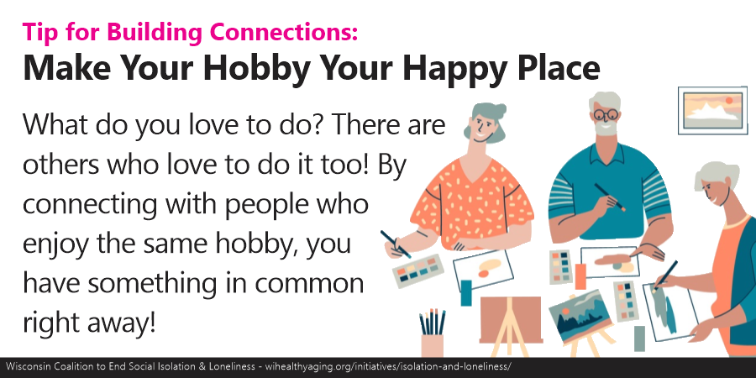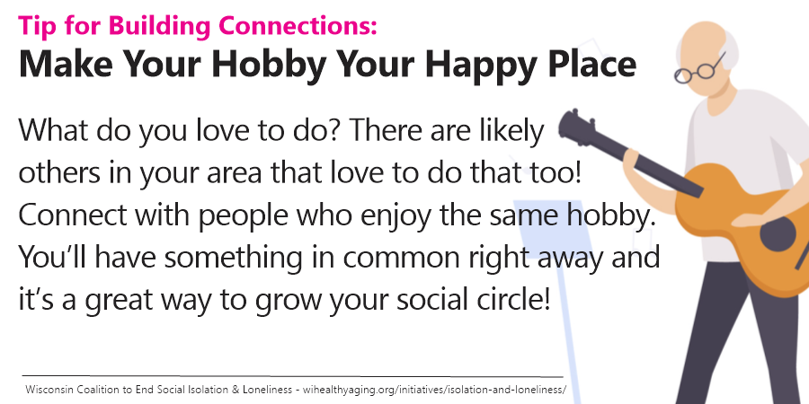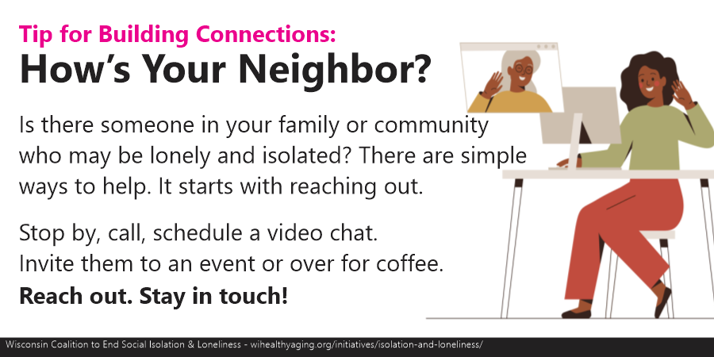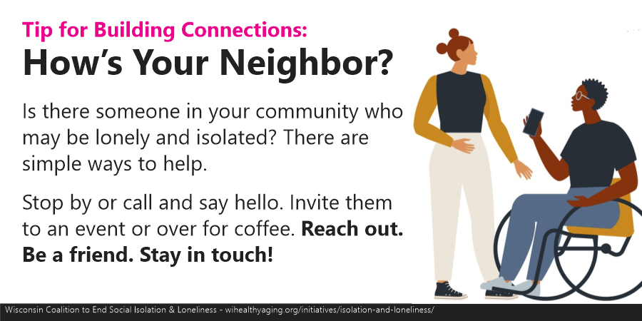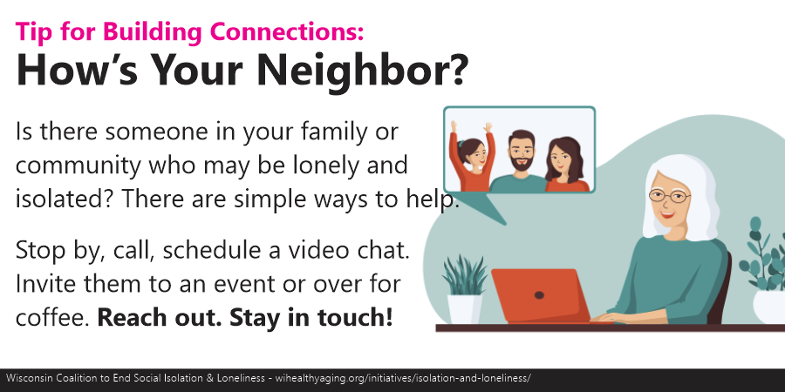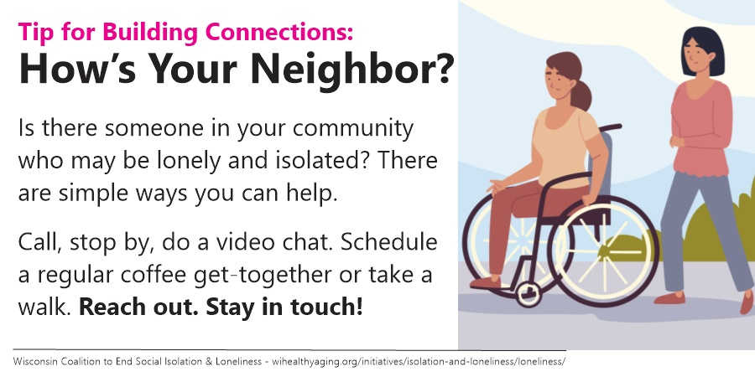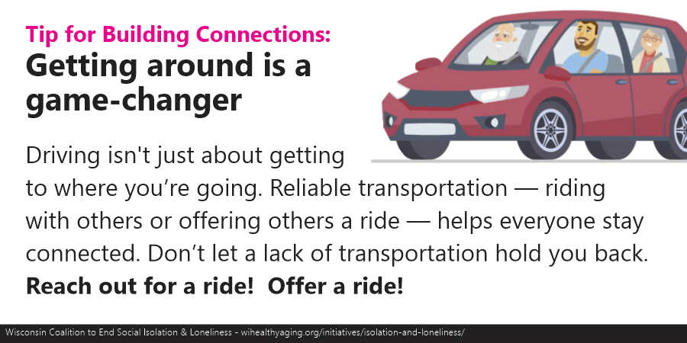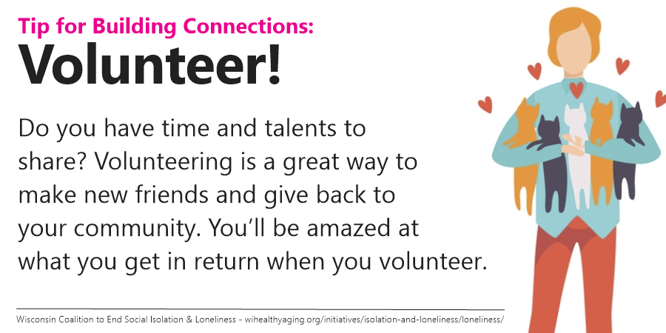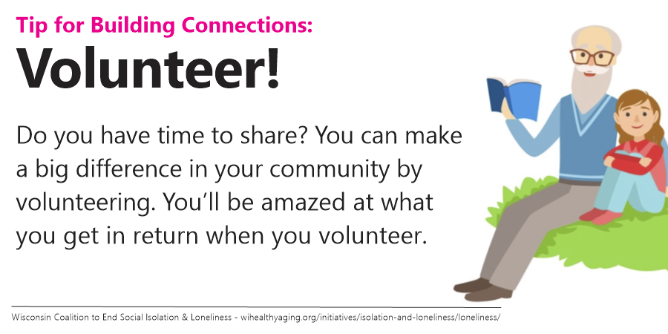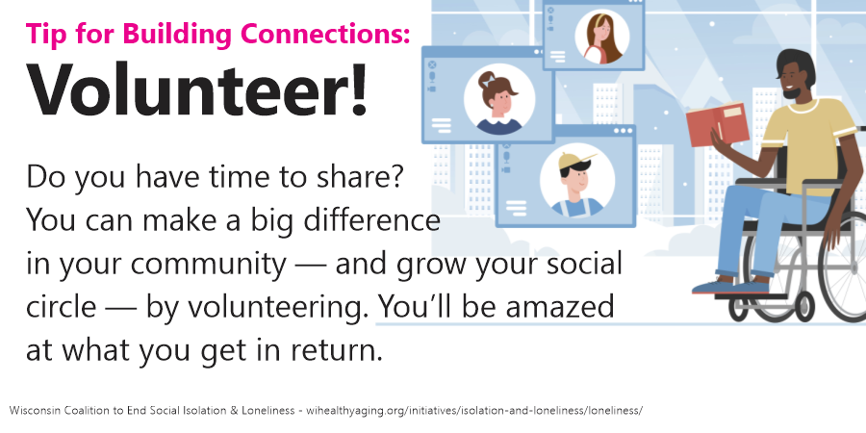

Data/Background information on social isolation and loneliness:
- Everyone needs social connections to survive and thrive. But as people age, they often find themselves spending more time alone. Being alone may leave older adults more vulnerable to loneliness and social isolation, which can affect their health and well-being.
- Studies show that loneliness and social isolation are associated with higher risks for health problems such as heart disease, depression, and cognitive decline.
- You also may be at greater risk if you:
  - Live alone
  - Can’t leave your home
  - Had a major loss or life change, such as the death of a spouse or partner, or retirement
  - Struggle with money
  - Are a caregiver
  - Have psychological or cognitive challenges, or depression
  - Have limited social support
  - Have trouble hearing
  - Live in a rural, unsafe, and/or hard-to-reach neighborhood
  - Have language barriers where you live
  - Experience age, racial, ethnic, sexual orientation, and/or gender identity discrimination where you live
  - Are not meaningfully engaged in activities or are feeling a lack of purpose
  - People with hearing loss may find it hard to have conversations with friends and family, which can lead to less interaction with people, social isolation, and higher rates of loneliness.
- While Black people are less likely to live alone than non-Hispanic Whites, factors like race-related stress, low income, lower quality neighborhood and community environments can accumulate over a lifetime and increase social isolation. (National Center for Biotechnology Information, National Library of Medicine)
- For the LGBTQ community, social isolation may result from legal structures, institutional policies, and cultural norms that create a sense of otherness. (Hatzenbuehler & Keyes, 2013). SI can also occur from interpersonal rejection, bullying, and stigma.
- LGBTQ older adults are twice as likely to live alone as non-LGBTQ adults and often face social isolation and vulnerability. (SAGE, Diverse Elders Coalition, 2022).
- Fifty-nine percent of LGBTQ older people report feeling a lack of companionship and 53 percent report feeling isolated from others. (Fredriksen-Goldsen, Aging and Health).
- Black people are six times more likely and Latinxs three times more likely than White people to rely on public transit (Center for social inclusion). Lack of access to reliable transportation decreases community members’ social connectedness.

Data/Background information on SIL in Older Adults:
A study by the National Academies of Sciences, Engineering, and Medicine showed:
- More than one-third of adults aged 45 and older feel lonely, and nearly one-fourth of adults aged 65 and older are socially isolated.
- 30% of U.S. households have a single member; approximately 34.75 million people live in single-person households.
- Social isolation significantly increased a person’s risk of premature death from all causes, a risk that may rival those of smoking, obesity, and physical inactivity.
- Social isolation was associated with about a 50% percent increased risk of dementia.
- Poor social relationships (characterized by social isolation or loneliness) was associated with a 29% increased risk of heart disease and a 32% increased risk of stroke.
- Loneliness among heart failure patients was associated with a nearly 4 times increased risk of death, 68% increased risk of hospitalization, and 57% increased risk of emergency department visits.

Data/Background information on SIL in People with Disabilities:
A Michigan University health policy brief developed under a grant from the National Institute on Disability, Independent Living, and Rehabilitation Research showed:
- 40% of adults with a debilitating disability or chronic condition report feeling lonely or socially isolated.
- Specific health risks associated with social isolation and loneliness include: increased mortality, increased blood pressure and progression of Alzheimer’s Disease, depression, pain, and fatigue, failing immune system, and decreased restorative sleep.
- Adults with disability have unequal access to technology which can increase a person’s risk of experiencing loneliness and isolation.

Data/Background information on volunteering as a strategy to address social isolation and loneliness:
Volunteers in Wisconsin have an incredible impact on our state and local communities, having a profound impact on the lives of their fellow Wisconsin residents. Information and data on group participation, social connectedness, and other volunteering and civic life indicators can be found for the state of Wisconsin or the United States as a whole in most recent Volunteering in America report. This data demonstrates the substantial impact of volunteers, as in 2017, Wisconsin had 1,718,821 volunteers contribute 164.3 million hours of service, with 37.4% of residents providing volunteer service worth an estimated $3.9 billion. Additionally, the Milwaukee metropolitan region ranked 4th in the nation for cities, with 44.6% of its residents volunteering.
- Volunteers report better physical and mental health compared to non-volunteers. Research has shown that volunteering leads to lower rates of depression and anxiety, especially for people 65 and over.
- By spending time in service to others, volunteers report feeling a sense of meaning and appreciation, both given and received, which can have a stress-reducing effect. Reduced stress further decreases risk of many physical and mental health problems, such has heart disease, stroke, depression, anxiety and general illness. In addition, a Longitudinal Study of Aging found that individuals who volunteer have lower mortality rates than those who do not, even when controlling for age, gender and physical health (Mayo Clinic Health System).
- Volunteering can help:
  - Reduce stress
  - Increase happiness
  - Develop confidence
  - Find purpose
  - (NAMI, 2022)
- Benefits of Volunteering that effect mental health and social isolation
  - Broader social networks
  - Decreased anxiety and depression
  - Research confirmed increases in happiness
  - Longer lifespans
  - Increased movement
  - Stress relief
  - (UMM, 2022)
Data/Background information on transportation as a strategy to address social isolation and loneliness:
- Accessible transportation services are critical for older adults and people with disability to live a more connected life (NADTC and RHIhub).
- The inability or loss of the ability to drive can increase the individual’s risk of experiencing isolation and loneliness (AE Barrett).
- Transportation is one of the most common supports provided by family care givers. Seventy-eight percent of caregivers provide or arrange for rides for their loved ones (NADTC).

Resources:
Category of Resource | Resource
Interventions / Programming | Customizable Social Isolation and Loneliness Resource Guide:  https://docs.google.com/document/d/1CUfubg3GoDC8beQyxc2UX5uqr2KHXoXY54KrZPeoF_A/edit  engAGED Social Engagement Innovations Hub  https://www.engagingolderadults.org/hub  Hello4Health  https://hello4health.org/connection-activities/  Cycling Without Age:  https://wisconsinbikefed.org/what-we-do/programs/cycling-without-age/  211 WI database:  www.211wisconsin.org  211 WI Caregiver Guided Search:  https://211wisconsin.communityos.org/caregiver18andolder
Outreach / Messaging | Social Isolation and Loneliness Outreach Toolkit by NIH National Institute on Aging  https://www.nia.nih.gov/ctctoolkit#resources
Individual Supports | Staying OK  Engaged-Staying OK: Tips for supporting your social connections and emotional wellness (squarespace.com)  Connect2Affect: Self-Assessment  https://connect2affect.org/  Tips for Staying Connected:  https://www.nia.nih.gov/health/loneliness-and-social-isolation-tips-staying-connected  Far From Alone:  https://farfromalone.com/  Find Help:  https://www.findhelp.org/  Family Caregiver Toolkit:  https://states.aarp.org/wisconsin/caregiver-resources  Caregiver Support Program:  https://www.unitedwaywi.org/page/caregiversupport  Healthy, Safe and Connected Toolkit:  English:  https://wi-bpdd.org/wp-content/uploads/2022/08/Healthy_Safe_Connected_V08.22.pdf  Spanish:  https://wi-bpdd.org/wp-content/uploads/2022/07/Spanish_Healthy_Safe_Connected_V05.22_fillable-003.pdf  Hmong:  https://wi-bpdd.org/wp-content/uploads/2022/07/Hmong_Healthy_Safe_Connected_V05.22_fillable-002.pdf  211 WI database:  www.211wisconsin.org  211 WI Caregiver Guided Search:  https://211wisconsin.communityos.org/caregiver18andolder
Volunteering | Websites to connect to volunteering:  https://www.volunteer.gov/s/  https://www.justserve.org/  https://engage.pointsoflight.org/  https://www.volunteermatch.org/volunteers/  https://americorps.gov/serve/americorps-seniors  https://www.volunteerwisconsin.org/  https://www.unitedwaywi.org/page/local  Sign up to be a trishaw Pilot with Cycling Without Age: Volunteer Pilot Interest Form

Action Steps to Promote:
- Reach out to your neighbor or family member who you haven’t talked with in a while.
- Start a group with folks who have similar interests as yours!
- Volunteer in your community!
  - To get connected to a volunteer opportunity near you: check-out listings at www.volunteerwisconsin.org or dial 211 from your cell phone or landline anywhere in Wisconsin. If you cannot make contact by dialing 211, call 877-947-2211.
- Reach out to get or give a ride.
  - For information about ride services dial 211 from your cell phone or landline anywhere in Wisconsin. If you cannot make contact by dialing 211, call 877-947-2211.
- Join the Wisconsin Coalition to End Social Isolation and Loneliness.
  - Join as an individual
  - Join as an organization
- Reach out to your community leaders to find out how they are addressing social isolation and loneliness

