Zoom Whiteboard
- In a zoom meeting, click to share your screen. Then, instead of clicking one of your screens, click “Whiteboard”
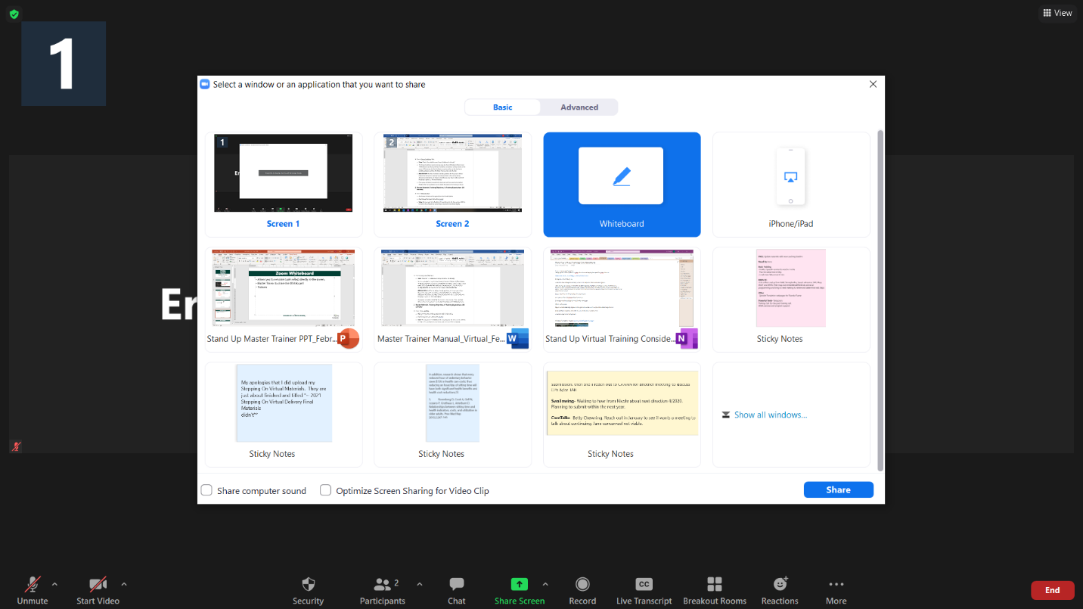

- If you go to the three dots and click more settings, then you can adjust who can annotate (whether participants can or cannot) and whether to show or hide the names of who is annotating.
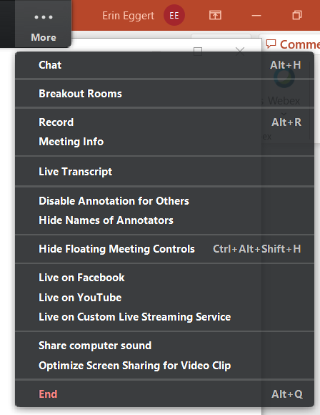
- After you allow participants to annotate, you will need to tell them to turn on annotation by going to the top bar in zoom and clicking “view options” and then annotate.
- Anyone who has their annotate turn to ‘on’ will get this toolbar:

Select- to take what you’ve annotated and move it around the screen
Text- to write text on the screen
Draw- to draw on the screen
Stamp- a few select stamps included that people can use to add to the screen
Spotlight-
Erase- to erase what you’ve included
Format- to select color for your text or drawing
Undo
Redo
Clear- clear all
Save- to save to desktop as pdf or jpg.

